GLASS: Distributed Ledger

Project Initiation Report

Authored by:

*Ben McKenzie (40536785), Conor King (40532386), Gabor Uzonyi (40429825), Kisimov Valentin (40439132), Ross Hunter (40478443), Stephen Park (40534021)*

Table of Contents

Purpose and Expected Benefits 3

Expected Cost and Deadline 3

Requirements and Quality Expectations 4

Stakeholder list 4

MoSCoW Priorities: 5

Deliverables Map 6

Communication Methods 6

Follow-up Registrar 7

Client Signature 8

Project Initiation peer review 9

Project description 9

Deliverables map 9

Follow-up register 9

Quality of document (clarity, presentation, etc.) 10

# Purpose and Expected Benefits

In this project the team will develop a system based on the GLASS research project, which aims to provide a delivery method of sharing EU citizen data with other member states to facilitate movement within the EU free travel zone. While also aiming to enhance the level of trust between EU citizens and government bodies by providing increased levels of transparency and security while also avoiding the bloat of previous administration bureaucracy.

To achieve these two main technologies will be used: Inter-Planetary File System (IPFS) and Hyperledger Fabric. The final product will not be a replica of the product being developed by the GLASS research team but will be scaled down in scope and function to properly fit within current time constraints.

The Hyperledger fabric is a modular blockchain framework which acts as a foundation for developing any blockchain products, solutions, and applications using components that are aimed for use within private enterprises. We shall be applying this within this GLASS research project.

IPFS is a distributed system for storing and accessing files, websites, applications, and data. IPFS aims to provide a more secure and optimised file sharing method using peer-to-peer systems.

The reason to create the second implantation is to test certain future and assess different attributes of the system. Moreover, the second implantation could help the researcher to make the final product more secure, more scalability, more privacy oriented via assessing both implantations.

# Expected Cost and Deadline

The deadline for this project is the 29th of April 2022. This is set by the University and is not subject to change.

For this project there are no expected monetary costs that the team is made aware of. However, there are resources available if required, these include:

* Technical guidance from subject experts
* Hardware and Software specific to the project

Other resources can be requested and will be considered by the client.

# Requirements and Quality Expectations

There are three main requirements for this project:

* Create a private IPFS network and securing this network for use in public channels. This would include the encryption of any stored and data and its transmission through secure peer to peer protocols.
* Create a Hyperledger Fabric blockchain that allows the collection of data with a realistic data set to mimic a real-world deployment.
* Finally combining these two services to produce an IPFS network that provides storage of content pointers to relevant blockchain entries that also establishes a secure access control policy.

# Stakeholder list

The following is a list of key stakeholders in the project, it will include their role and relevant contact information.

Ben McKenzie, Project Manager and Team member, [40536785@live.napier.ac.uk](mailto:40478443@live.napier.ac.uk)

Conor King, Team member, [40532386@live.napier.ac.uk](mailto:40532386@live.napier.ac.uk)

Gabor Uzonyi, Team member, [40429825@live.napier.ac.uk](mailto:40429825@live.napier.ac.uk)

Kisimov Valentin, Team member, [40439132@live.napier.ac.uk](mailto:40439132@live.napier.ac.uk)

Ross Hunter, Team member, [40478443@live.napier.ac.uk](mailto:40478443@live.napier.ac.uk)

Stephen Park, Team member, [40534021@live.napier.ac.uk](mailto:40534021@live.napier.ac.uk)

Nikolaos Pitropakis, Associate Professor and Project Client, [n.pitropakis@napier.ac.uk](mailto:n.pitropakis@napier.ac.uk)

Sarwar Sayeed, Research Assistant and Technical Resource, [s.sayeed@napier.ac.uk](mailto:s.sayeed@napier.ac.uk)

Owen Lo, Research Assistant and Technical Resource, [O.Lo@napier.ac.uk](mailto:O.Lo@napier.ac.uk)

Nagmeh Moradpoor Sheykhkanloo, Lecturer and Project supervisor, [n.moradpoor@napier.ac.uk](mailto:n.moradpoor@napier.ac.uk)

# MoSCoW Priorities:

|  |  |
| --- | --- |
| ***M***ust-have | * Create a private IPFS network that provides secure permission-based content storage and peer to peer communication   + Store Personal information in the IPFS such as NI number, Ful legal name, date of birth, passport number, mother name, home address * Development of Hyperledger Fabric with Private Data Collection feature and multiple Peers and Organizations which mimics real-world scenario * A Hyperledger Fabric blockchain that provides content links to data stored on the IPFS network * Combination of both IPFS and Hyperledger fabric * An audit trail of all transactions to have transparency inside of the government * Immutability once a transaction is validated and committed * Read-only queries using a rich query language |
| ***S***hould | * Exploration of scaling the private network to a public one securely, using encryption * Deploying a Hyperledger Fabric channel which contains a configuration block defining policies, access control lists, and other pertinent information * Query and update ledger using key-based lookups * Identity verification on an update and query request |
| ***C***ould-have | * Method of automatically creating a private IPFS network using Ansible or other scripting methods * Read-only history queries — Query ledger history for a key, enabling data provenance scenarios * Peers validate transactions against endorsement policies and enforce the policies. * Prior to appending a block, a versioning check is performed to ensure that states for assets that were read have not changed since chaincode execution time * Encrypting of values and be only decrypted by the peer with the key. |
| ***W***on't-have | * Backups for the IPFS /HLF for 51% attacks etc * Creation of separate channels by participants. * property/car ownership via erc721 * Preventing insiders to create fake identities: 2 wallets need sign birth certificate |

Fig 1: MoSCoW Table

# Deliverables Map

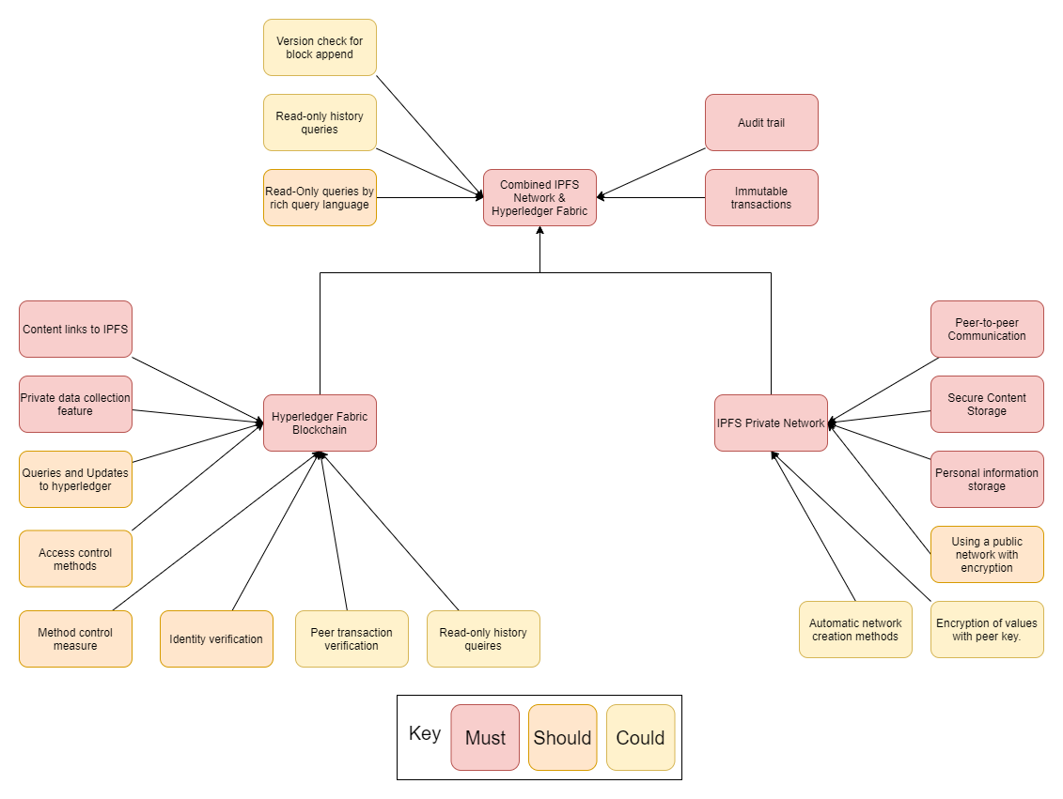Fig 2: Deliverables Map

The Deliverables Map shown in *Fig 2* describes the three core aspects of this project: Hyperledger Fabric Blockchain, IPFS Private network and the combination of these two technologies. Using the priorities defined in the MoSCoW table *fig 1* a key was created to highlight the priority of the deliverables in a visual format.

# Communication Methods

We have requested a Team group to be created for our project. The group has decided to use MS Team exclusively for all types of communication, such as conference calls and chat. We have created multiple channels in the MS Teams group: Team-Client, Team-Sponsor, and Group therefore all communication happens in that group.

Using the Microsoft Team platform allows us to use the Group as a PMIS. We have Microsoft SharePoint connected to the channel therefore we can share files and multiple members can edit a file simultaneously. Moreover, we have added numerous apps to the group such as task board, whiteboard, meeting notes, and Visio. This application will make our communication easier and more efficient which will help us succeed as a team.

All program code will be committed to a private GitHub repository. Therefore, all code will be backup in the cloud as well as local on all member machines.

# Follow-up Registrar

|  |  |  |  |
| --- | --- | --- | --- |
| Cause | Effect | Impact | Response |
| Technical issues regarding installing Hyperledger | Inability to work on the project | Failing to deliver a fully functional project | Seeking help from project's technical advisors |
| Technical issues with working IPFS network | Inability to work on the project | Failing to deliver a fully functional project | Seeking help from project's technical advisors |
| Version control and code synchronization | Inefficiency and lost data | Troubleshooting issues that are not relevant and time waste | Using a tested and proven workflow technique |
| Spending time and resources on insignificant features of the project | Inefficiency and time loss | Failing to deliver a fully functional project | Carefully prioritizing key features and focusing on them first |
| Poor efficiency in general | Time loss and inability to deliver on time | Failing to deliver a fully functional project | Team discussion on possible solutions |
| Unequal team participation | inequal work required from different team members and efficiency problems | failing to deliver a fully functional project | Planning and assigning tasks carefully |
| Team member has COVID-19 or is unwell | Difficulty in completing tasks which are dependent on the team member | Lower efficiency  Missing deadlines | Taking meeting notes and creating summaries which are read by the vacant team member. |
| Team members cannot attend a group meeting | Difficulty in completing tasks which are dependent on the team member | Lower efficiency  Missing deadlines | Creating summaries what has been discussed and asks the vacant team member for any further input they |
| In-Team Communication Issues | Poor Efficiency and misunderstandings | Failing to deliver a fully functional project | Team discussion on possible solutions |

Fig 3: Flow up table

# Client Signature

**Nikolaos Pitropakis**

# Project Initiation peer review

**Reviewer:**  **Gavin Vincenti** **Team: 154**

**Reviewee:** **Ben McKenzie**  **Team: 109**

**Date of review: 17/02/2022**

## Project description

**Reviewer’s comments and recommendations**

No explanation for what Inter-Planetary File System (IPFS) and Hyperledger Fabric is? Cost and deadline are very clear but overall punctuation could be improved

**Response and actions taken**

The contents and description of the IPFS and hyper ledger is available on the GLASS project site.

Proofread and review of document has been completed to prevent or correct any grammatical or punction errors.

## Deliverables map

**Reviewer’s comments and recommendations**

Project Map very well done. Very readable and clear on project deliverables. Could write a short description about what the deliverable map is and what it entails

**Response and actions taken**

Added a brief description to the deliverables map to describe what is being shown and how they link together.

## Follow-up register

**Reviewer’s comments and recommendations**

Overall, very clear and concise

Could create some contrast in the register as it is all done in the same colour, font, and size

**Response and actions taken**

Overall readability of the document has been improved.

## Quality of document (clarity, presentation, etc.)

**Reviewer’s comments and recommendations**

Quite a few spelling and punctuation mistakes throughout the report, needs to be properly proofread. Better use of Bolds and Italics could be used to make project look more presentable

**Response and actions taken**

Spellings, punctuation, and document formatting has been improved.